**Text Mining**

**Extracting Reviews from Amazon**

**Latent Dirichlet Allocation**

Topic 1 Topic 2 Topic 3 Topic 4 Topic 5 Topic 6 Topic 7

[1,] "works" "good" "google" "speaker" "music" "sound" "music"

[2,] "support" "speaker" "bad" "sound" "speaker" "speaker" "plays"

[3,] "devices" "sound" "eco" "music" "dot" "dot" "amazed"

[4,] "dot" "smart" "home" "plays" "sound" "internet" "quality"

[5,] "home" "stuff" "mini" "amazon" "bass" "amazon" "callhapppy"

Topic 8 Topic 9 Topic 10

[1,] "songs" "music" "speaker"

[2,] "amazing" "amazon" "sound"

[3,] "play" "good" "music"

[4,] "call" "apps" "the"

[5,] "understand" "however" "dot"

**10 topics with 5 terms each**

**Sentiment Analysis**

**Six methods for sentiment analysis**

**syuzhet , afinn, bing, nrc, Stanford, custom**

**Analyzing using “nrc”**

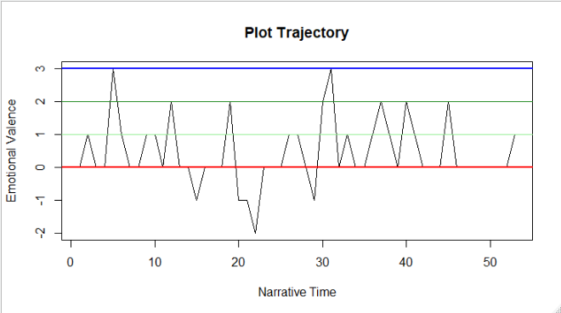

**From the above plot, we can clearly see that positive review reached +3 and negative review -2.**

**Analyzing using “bing”**

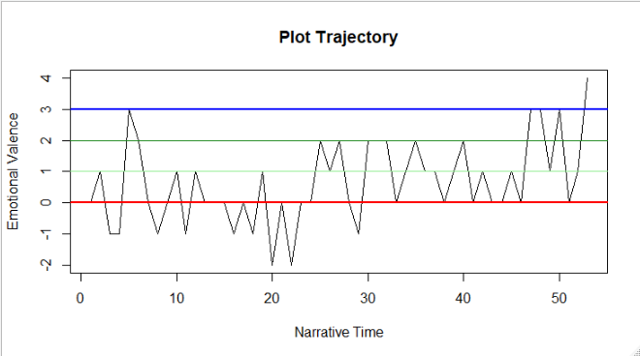**Based on above plot, positive review crosses the +3 while negative review is up to -2.**

**Emotion Analysis**

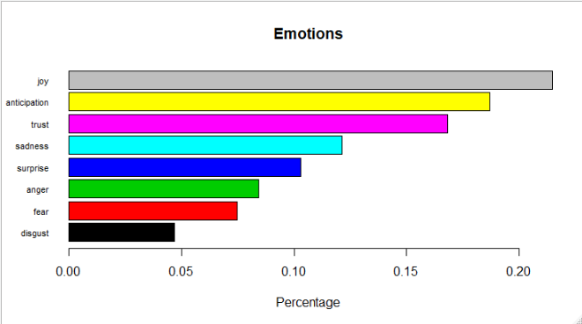**Reviews contain more joyful words.**

**Word Cloud**

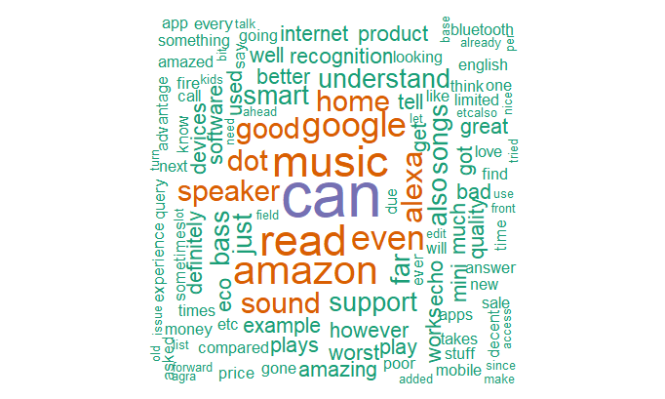

**Unique words word cloud**

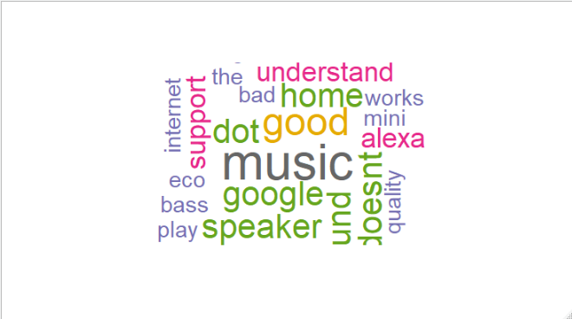

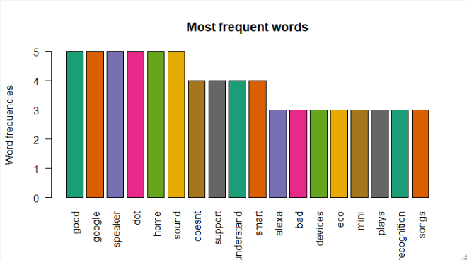

**From the word cloud and barplot we can say that Alexa echo dot is good in-home sound system.**